**Supplementary materials**

**Exploration of the yeast metabolism during fermentation through the differential gene expression analysis**

1. **Downloading the data**Reads before the fermentation (2 replicates):wget <http://ftp.sra.ebi.ac.uk/vol1/fastq/SRR941/SRR941816/SRR941816.fastq.gz>  
   wget <http://ftp.sra.ebi.ac.uk/vol1/fastq/SRR941/SRR941817/SRR941817.fastq.gz>  
   Reads after the fermentation (2 replicates):  
   wget <http://ftp.sra.ebi.ac.uk/vol1/fastq/SRR941/SRR941818/SRR941818.fastq.gz>  
   wget <http://ftp.sra.ebi.ac.uk/vol1/fastq/SRR941/SRR941819/SRR941819.fastq.gz>  
   Yeast reference genome:  
   wget <http://ftp.ncbi.nlm.nih.gov/genomes/all/GCF/000/146/045/GCF_000146045.2_R64/GCF_000146045.2_R64_genomic.fna.gz>  
   Yeast annotation:  
   wget <http://ftp.ncbi.nlm.nih.gov/genomes/all/GCF/000/146/045/GCF_000146045.2_R64/GCF_000146045.2_R64_genomic.gff.gz>  
   Yeast transcriptome:  
   wget <https://ftp.ncbi.nlm.nih.gov/genomes/all/GCF/000/146/045/GCF_000146045.2_R64/GCF_000146045.2_R64_rna.fna.gz>
2. **Differential expression analysis  
   a) Aligning with HISAT2**Building genome index:  
   gunzip GCF_000146045.2_R64_genomic.fna.gz  
   hisat2-build GCF_000146045.2_R64_genomic.fna genomic  
   Alignment on the genome:  
   gunzip SRR941816.fastq.gz SRR941817.fastq.gz SRR941818.fastq.gz SRR941819.fastq.gz  
   hisat2 -p 2 -x ./genomic -U SRR941816.fastq | samtools sort > R0_1.bam  
     
   9043877 reads; of these:

9043877 (100.00%) were unpaired; of these:

520137 (5.75%) aligned 0 times

7929704 (87.68%) aligned exactly 1 time

594036 (6.57%) aligned >1 times

94.25% overall alignment rate  
  
hisat2 -p 2 -x ./genomic -U SRR941817.fastq | samtools sort > R0_2.bam  
  
9929568 reads; of these:

9929568 (100.00%) were unpaired; of these:

511726 (5.15%) aligned 0 times

8644592 (87.06%) aligned exactly 1 time

773250 (7.79%) aligned >1 times

94.85% overall alignment rate  
  
hisat2 -p 2 -x ./genomic -U SRR941818.fastq | samtools sort > RF_1.bam  
  
1721675 reads; of these:

1721675 (100.00%) were unpaired; of these:

66368 (3.85%) aligned 0 times

1507910 (87.58%) aligned exactly 1 time

147397 (8.56%) aligned >1 times

96.15% overall alignment rate  
  
hisat2 -p 2 -x ./genomic -U SRR941819.fastq | samtools sort > RF_2.bam  
  
6172452 reads; of these:

6172452 (100.00%) were unpaired; of these:

234528 (3.80%) aligned 0 times

5367724 (86.96%) aligned exactly 1 time

570200 (9.24%) aligned >1 times

96.20% overall alignment rate  
  
**b) Quantifying with featureCounts**Converting GFF to GTF:  
sudo apt install gffread  
gunzip GCF_000146045.2_R64_genomic.gff.gz  
gffread GCF_000146045.2_R64_genomic.gff -T -o gen_ann.gtf  
featureCounts:  
featureCounts -g gene_id -a gen_ann.gtf -o fc R0_1.bam R0_2.bam RF_1.bam RF_2.bam  
Simplifying the counts:  
cat fc | cut -f 1,7-10 > simple_counts.txt  
  
**c) Finding of the differentially expressed genes with Deseq2**

1. **Deseq2 analysis**

# Load the library

library(DESeq2)

# Set up the conditions based on the experimental setup.

cond_1 = rep("cond1", 2)

cond_2 = rep("cond2", 2)

# Read the data from the standard input.

countData = read.table("simple_counts.txt", header=TRUE, sep="\t", row.names=1 )

# Build the dataframe from the conditions

samples = names(countData)

condition = factor(c(cond_1, cond_2))

colData = data.frame(samples=samples, condition=condition)

# Create DESEq2 dataset.

dds = DESeqDataSetFromMatrix(countData=countData, colData=colData, design = ~condition)

#Set the reference to be compared

dds$condition = relevel(dds$condition,"cond1")

# Run deseq

dds = DESeq(dds)

# Format the results.

res = results(dds)

#Volcano Plot

EnhancedVolcano(res,

lab = rownames(res),

x = 'log2FoldChange',

y = 'pvalue',

pCutoff = 0.001)

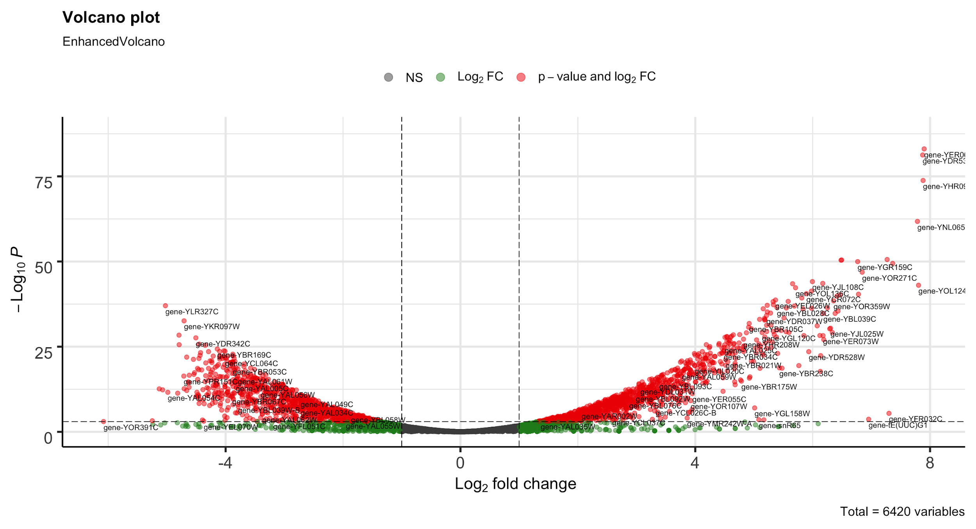

# Sort the results data frame by the padj and foldChange columns.

sorted = res[with(res, order(padj, -log2FoldChange)), ]

# Turn it into a dataframe to have proper column names.

sorted.df = data.frame("id"=rownames(sorted),sorted)

# Number of genes which expкession is significant change

nrow(sorted.df[sorted.df$padj<0.001, ])

2508

# Select 50 genes with up- and downregulation

overexpression = sorted.df[sorted.df$log2FoldChange>0, "id"][1:50]

downregulated = sorted.df[sorted.df$log2FoldChange<0, "id"][1:50]

# Write the table out.

write.table(sorted.df, file="result.txt", sep="\t", col.names=NA, quote=FALSE)

# Get normalized counts and write this to a file

nc = counts(dds,normalized=TRUE)

# Turn it into a dataframe to have proper column names.

dt = data.frame("id"=rownames(nc),nc)

# Save the normalize data matrix.

write.table(dt, file="norm-matrix-deseq2.txt", sep="\t", row.name=FALSE, col.names=TRUE,quote=FALSE)

**2. Heatmap**

library(gplots)

# Read normalized counts

data = read.table("norm-matrix-deseq2.txt", header=T, sep="\t", as.is=TRUE)

gene = data[,1]

vals = as.matrix(data[,2:ncol(data)])

# Adds a little noise to each element

# To avoid the clusteing function failing on zero

# variance datalines.

vals = jitter(vals, factor = 1, amount=0.00001)

# Calculate zscore

score = NULL

for (i in 1:nrow(vals)) {

row=vals[i,]

zscore=(row-mean(row))/sd(row)

score =rbind(score,zscore)

}

row.names(score) = gene

zscore=score

# Generate heatmap

mat = as.matrix(zscore)

# Open the drawing device.

pdf('output.pdf')

colors = colorRampPalette(c("green","black","red"),space="rgb")

heatmap.2(mat,col=colors,density.info="none",trace="none", margins=c(14,14),lhei=c(1,5))

invisible(dev.off())

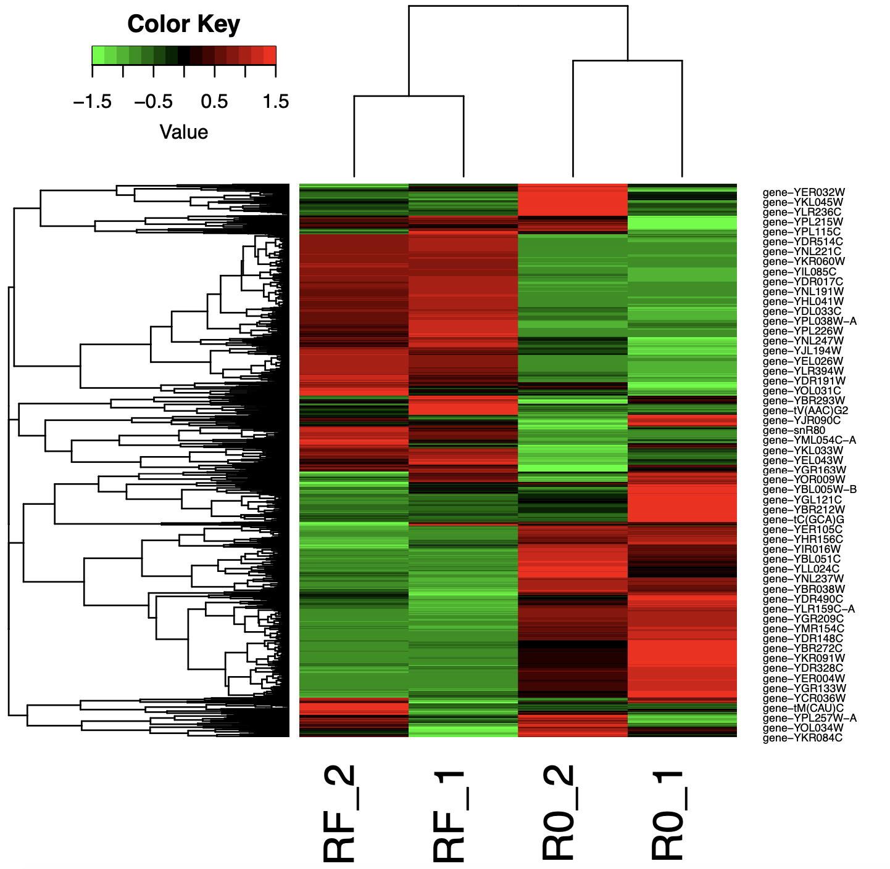

Original code attached for this project:

<https://figshare.com/articles/software/Scripts_for_RNA-seq_project/14239304>

Calculation of the metrics:

cat simple_counts.txt | R -f deseq2.r

Drawing of the heatmap and volcano plot:

cat norm-matrix-deseq2.txt | R -f draw-heatmap.r

**3. Result Interpretation**

Extraction of the 50 first results:

cat result.txt | head -n 50 | cut -f 1 > genes.txt

cat genes.txt | cut -d- -f2 > gene_id.txt

Using gene ontology terms to get a sense of what these genes are doing:

- upload **genes_id.txt**

- select “Yeast GO-Slim: Process”

- “SELECT ALL TERMS” is highlighted

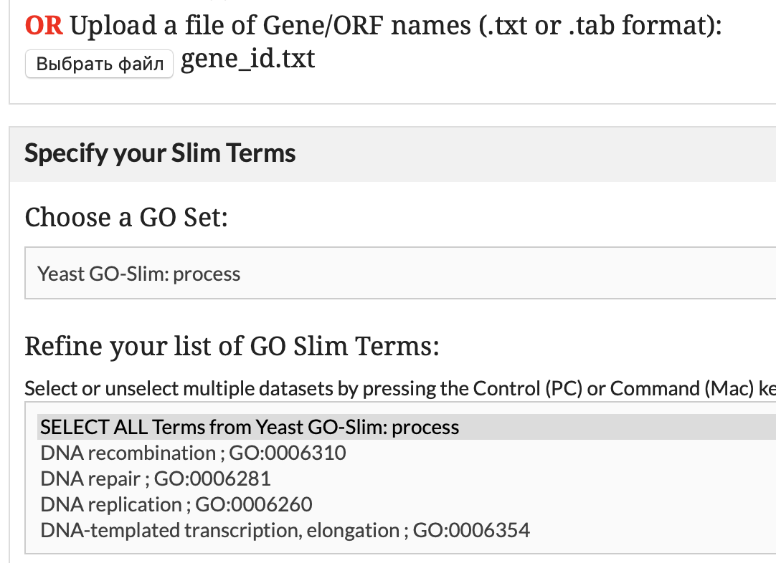

Table 1 - GO terms of genes with differential expression (first 50 by p-value).

|  |  |  |  |  |  |  |
| --- | --- | --- | --- | --- | --- | --- |
| **GO ID** | **TERM** | **NUMLIST ANNOTATIONS** | **CLUSTER FREQUENCY** | **TOTAL NUM ANNOTATIONS** | **GENOME FREQUENCY** | **ANNOTATED GENES** |
| GO:0006364 | rRNA processing | 13 | 27.08% | 366 | 5.68% | YDR449C, YEL026W, YER127W, YGR159C, YHR066W, YHR196W, YJL069C, YLR264W, YMR093W, YNL112W, YNL182C, YOL041C, YOL080C |
| GO:0042273 | ribosomal large subunit biogenesis | 9 | 18.75% | 130 | 2.02% | YCR072C, YDL063C, YEL026W, YHR066W, YIR012W, YJL122W, YNL182C, YOL041C, YOL080C |
| GO:0042274 | ribosomal small subunit biogenesis | 8 | 16.67% | 146 | 2.27% | YDR449C, YEL026W, YER127W, YGR159C, YHR196W, YJL069C, YLR264W, YMR093W |
| GO:0042255 | ribosome assembly | 7 | 14.58% | 79 | 1.23% | YCR072C, YGR159C, YHR066W, YIR012W, YLR264W, YNL182C, YOL080C |
| GO:0006811 | ion transport | 6 | 12.50% | 340 | 5.28% | YDR536W, YHR094C, YKL120W, YNL065W, YNR060W, YOR271C |
| GO:0006360 | transcription by RNA polymerase I | 6 | 12.50% | 71 | 1.10% | YHR196W, YJL148W, YJR063W, YML043C, YMR093W, YNL248C |
| GO:0055085 | transmembrane transport | 5 | 10.42% | 468 | 7.26% | YDR536W, YHR094C, YKL120W, YNL065W, YOR271C |
| GO:0005975 | carbohydrate metabolic process | 4 | 8.33% | 253 | 3.93% | YBR105C, YER062C, YKR097W, YOL136C |
| GO:0055086 | nucleobase-containing small molecule metabolic process | 4 | 8.33% | 220 | 3.41% | YBL039C, YMR300C, YNL141W, YOL136C |
| GO:0006401 | RNA catabolic process | 3 | 6.25% | 166 | 2.58% | YLR264W, YNL112W, YOR359W |
| GO:0006520 | cellular amino acid metabolic process | 3 | 6.25% | 218 | 3.38% | YBL039C, YLR180W, YMR300C |
| GO:0006417 | regulation of translation | 3 | 6.25% | 234 | 3.63% | YLR264W, YNL112W, YOR359W |
| GO:0051052 | regulation of DNA metabolic process | 2 | 4.17% | 97 | 1.51% | YNL182C, YOR359W |
| GO:0042221 | response to chemical | 2 | 4.17% | 530 | 8.23% | YLR224W, YNL065W |
| GO:0006352 | DNA-templated transcription, initiation | 2 | 4.17% | 83 | 1.29% | YML043C, YNL248C |
| GO:0006354 | DNA-templated transcription, elongation | 2 | 4.17% | 109 | 1.69% | YJL148W, YNL248C |
| GO:0006629 | lipid metabolic process | 2 | 4.17% | 348 | 5.40% | YBL039C, YOL151W |
| GO:0051603 | proteolysis involved in cellular protein catabolic process | 2 | 4.17% | 265 | 4.11% | YBR105C, YLR224W |
| GO:0008643 | carbohydrate transport | 2 | 4.17% | 46 | 0.71% | YDR536W, YHR094C |
| GO:0015931 | nucleobase-containing compound transport | 2 | 4.17% | 183 | 2.84% | YHR196W, YLR264W |
| GO:0006353 | DNA-templated transcription, termination | 2 | 4.17% | 42 | 0.65% | YJR063W, YNL112W |
| GO:0006366 | transcription by RNA polymerase II | 2 | 4.17% | 556 | 8.63% | YJR063W, YNL112W |
| GO:0006865 | amino acid transport | 2 | 4.17% | 56 | 0.87% | YNL065W, YOR271C |
| GO:0009451 | RNA modification | 2 | 4.17% | 186 | 2.89% | YOL124C, YPL212C |
| GO:0008033 | tRNA processing | 2 | 4.17% | 134 | 2.08% | YOL124C, YPL212C |
| GO:0006310 | DNA recombination | 1 | 2.08% | 255 | 3.96% | YGR159C |
| GO:0006260 | DNA replication | 1 | 2.08% | 151 | 2.34% | YNL182C |
| GO:0070925 | organelle assembly | 1 | 2.08% | 125 | 1.94% | YLR180W |
| GO:0006605 | protein targeting | 1 | 2.08% | 256 | 3.97% | YBR105C |
| GO:0006397 | mRNA processing | 1 | 2.08% | 220 | 3.41% | YEL026W |
| GO:0006970 | response to osmotic stress | 1 | 2.08% | 73 | 1.13% | YER062C |
| GO:0006091 | generation of precursor metabolites and energy | 1 | 2.08% | 113 | 1.75% | YOL136C |
| GO:0002181 | cytoplasmic translation | 1 | 2.08% | 205 | 3.18% | YLR264W |
| GO:0033043 | regulation of organelle organization | 1 | 2.08% | 279 | 4.33% | YLR180W |
| GO:0006873 | cellular ion homeostasis | 1 | 2.08% | 162 | 2.51% | YNR060W |
| GO:0008380 | RNA splicing | 1 | 2.08% | 153 | 2.37% | YEL026W |
| GO:0070647 | protein modification by small protein conjugation or removal | 1 | 2.08% | 223 | 3.46% | YLR224W |
| GO:0032787 | monocarboxylic acid metabolic process | 1 | 2.08% | 164 | 2.55% | YOL136C |
| GO:0006418 | tRNA aminoacylation for protein translation | 1 | 2.08% | 37 | 0.57% | YDR037W |

Extraction of the up regulated genes:

overexpression = sorted.df[sorted.df$log2FoldChange>0, "id"][1:50]

YER062C YDR536W YHR094C YNL065W YKL120W YJL122W YLR264W YGR159C YNL112W YOR271C YJL108C YJL107C YOR360C YOL124C YOL136C YER127W YCR072C YLR180W YNL141W YML043C YMR300C YEL026W YOR359W YHR066W YGR079W YIR012W YJL148W YOL041C YBL028C YOL080C YDL063C YOL151W YHR196W YML018C YNR060W YPL212C YJR063W YLR264C-A YBL039C YDR037W YNL182C YDR449C YLR224W YMR093W YJL069C YBR105C YNL248C YER049W YKL078W YGR128C

<http://gotermfinder.yeastgenome.org/mapper_genes_11701_slimTerms.html>

Table 2 - GO terms for up regulated genes (first 50 by p-value).

|  |  |  |  |  |  |  |
| --- | --- | --- | --- | --- | --- | --- |
| **GO ID** | **TERM** | **NUMLIST ANNOTATIONS** | **CLUSTER FREQUENCY** | **TOTAL NUM ANNOTATIONS** | **GENOME FREQUENCY** | **ANNOTATED GENES** |
| GO:0006364 | rRNA processing | 15 | 30.00% | 366 | 5.68% | YDR449C, YEL026W, YER127W, YGR128C, YGR159C, YHR066W, YHR196W, YJL069C, YKL078W, YLR264W, YMR093W, YNL112W, YNL182C, YOL041C, YOL080C |
| GO:0042274 | ribosomal small subunit biogenesis | 10 | 20.00% | 146 | 2.27% | YDR449C, YEL026W, YER127W, YGR128C, YGR159C, YHR196W, YJL069C, YKL078W, YLR264W, YMR093W |
| GO:0042273 | ribosomal large subunit biogenesis | 9 | 18.00% | 130 | 2.02% | YCR072C, YDL063C, YEL026W, YHR066W, YIR012W, YJL122W, YNL182C, YOL041C, YOL080C |
| GO:0006360 | transcription by RNA polymerase I | 8 | 16.00% | 71 | 1.10% | YGR128C, YHR196W, YJL148W, YJR063W, YKL078W, YML043C, YMR093W, YNL248C |
| GO:0042255 | ribosome assembly | 7 | 14.00% | 79 | 1.23% | YCR072C, YGR159C, YHR066W, YIR012W, YLR264W, YNL182C, YOL080C |
| GO:0006811 | ion transport | 6 | 12.00% | 340 | 5.28% | YDR536W, YHR094C, YKL120W, YNL065W, YNR060W, YOR271C |
| GO:0055085 | transmembrane transport | 5 | 10.00% | 468 | 7.26% | YDR536W, YHR094C, YKL120W, YNL065W, YOR271C |
| GO:0055086 | nucleobase-containing small molecule metabolic process | 4 | 8.00% | 220 | 3.41% | YBL039C, YMR300C, YNL141W, YOL136C |
| GO:0006417 | regulation of translation | 4 | 8.00% | 234 | 3.63% | YER049W, YLR264W, YNL112W, YOR359W |
| GO:0006401 | RNA catabolic process | 4 | 8.00% | 166 | 2.58% | YER049W, YLR264W, YNL112W, YOR359W |
| GO:0015931 | nucleobase-containing compound transport | 3 | 6.00% | 183 | 2.84% | YGR128C, YHR196W, YLR264W |
| GO:0006520 | cellular amino acid metabolic process | 3 | 6.00% | 218 | 3.38% | YBL039C, YLR180W, YMR300C |
| GO:0005975 | carbohydrate metabolic process | 3 | 6.00% | 253 | 3.93% | YBR105C, YER062C, YOL136C |
| GO:0008033 | tRNA processing | 2 | 4.00% | 134 | 2.08% | YOL124C, YPL212C |
| GO:0008643 | carbohydrate transport | 2 | 4.00% | 46 | 0.71% | YDR536W, YHR094C |
| GO:0006353 | DNA-templated transcription, termination | 2 | 4.00% | 42 | 0.65% | YJR063W, YNL112W |
| GO:0006865 | amino acid transport | 2 | 4.00% | 56 | 0.87% | YNL065W, YOR271C |
| GO:0051603 | proteolysis involved in cellular protein catabolic process | 2 | 4.00% | 265 | 4.11% | YBR105C, YLR224W |
| GO:0006352 | DNA-templated transcription, initiation | 2 | 4.00% | 83 | 1.29% | YML043C, YNL248C |
| GO:0006354 | DNA-templated transcription, elongation | 2 | 4.00% | 109 | 1.69% | YJL148W, YNL248C |
| GO:0009451 | RNA modification | 2 | 4.00% | 186 | 2.89% | YOL124C, YPL212C |
| GO:0042221 | response to chemical | 2 | 4.00% | 530 | 8.23% | YLR224W, YNL065W |
| GO:0051052 | regulation of DNA metabolic process | 2 | 4.00% | 97 | 1.51% | YNL182C, YOR359W |
| GO:0006366 | transcription by RNA polymerase II | 2 | 4.00% | 556 | 8.63% | YJR063W, YNL112W |
| GO:0006629 | lipid metabolic process | 2 | 4.00% | 348 | 5.40% | YBL039C, YOL151W |
| GO:0006970 | response to osmotic stress | 1 | 2.00% | 73 | 1.13% | YER062C |
| GO:0006418 | tRNA aminoacylation for protein translation | 1 | 2.00% | 37 | 0.57% | YDR037W |
| GO:0070647 | protein modification by small protein conjugation or removal | 1 | 2.00% | 223 | 3.46% | YLR224W |
| GO:0006310 | DNA recombination | 1 | 2.00% | 255 | 3.96% | YGR159C |
| GO:0008380 | RNA splicing | 1 | 2.00% | 153 | 2.37% | YEL026W |
| GO:0002181 | cytoplasmic translation | 1 | 2.00% | 205 | 3.18% | YLR264W |
| GO:0006873 | cellular ion homeostasis | 1 | 2.00% | 162 | 2.51% | YNR060W |
| GO:0032787 | monocarboxylic acid metabolic process | 1 | 2.00% | 164 | 2.55% | YOL136C |
| GO:0006260 | DNA replication | 1 | 2.00% | 151 | 2.34% | YNL182C |
| GO:0033043 | regulation of organelle organization | 1 | 2.00% | 279 | 4.33% | YLR180W |
| GO:0018193 | peptidyl-amino acid modification | 1 | 2.00% | 256 | 3.97% | YER049W |
| GO:0006605 | protein targeting | 1 | 2.00% | 256 | 3.97% | YBR105C |
| GO:0006091 | generation of precursor metabolites and energy | 1 | 2.00% | 113 | 1.75% | YOL136C |
| GO:0070925 | organelle assembly | 1 | 2.00% | 125 | 1.94% | YLR180W |
| GO:0006397 | mRNA processing | 1 | 2.00% | 220 | 3.41% | YEL026W |
|  |  |  |  |  |  |  |

Extraction of the down regulated genes:

downregulated = sorted.df[sorted.df$log2FoldChange<0, "id"][1:50]

YLR327C YKR097W YMR081C YDR342C YCR021C YNL117W YNR001C YBR169C YCL040W YJR073C YPL231W YDR343C YEL011W YMR186W YLR174W YNR034W-A YNL077W YFR015C YDR171W YNL015W YPL240C YGR008C YCL064C YLR304C YNR016C YNL194C YOL016C YIL169C YIL155C YBR214W YDL130W-A YPL004C YNL055C YGR157W YDR216W YBR149W YLR411W YKL182W YOL155C YKL085W YLR133W YOR027W YNL173C YIL162W YPR006C YPR184W YBR053C YKL109W

YBR072W YMR031C

<http://gotermfinder.yeastgenome.org/mapper_genes_11738_slimTerms.html>

Table 3 - GO terms for down regulated genes (first 50 by p-value)

|  |  |  |  |  |  |  |
| --- | --- | --- | --- | --- | --- | --- |
| **GO ID** | **TERM** | **NUMLIST ANNOTATIONS** | **CLUSTER FREQUENCY** | **TOTAL NUM ANNOTATIONS** | **GENOME FREQUENCY** | **ANNOTATED GENES** |
| GO:0005975 | carbohydrate metabolic process | 13 | 26.00% | 253 | 3.93% | YBR053C, YBR149W, YCL040W, YEL011W, YFR015C, YIL155C, YIL162W, YKL085W, YKR097W, YLR174W, YNL117W, YNR001C, YPR184W |
| GO:0032787 | monocarboxylic acid metabolic process | 7 | 14.00% | 164 | 2.55% | YCL040W, YKL182W, YLR174W, YNL117W, YNR016C, YPL231W, YPR006C |
| GO:0045333 | cellular respiration | 7 | 14.00% | 116 | 1.80% | YKL085W, YKL109W, YLR174W, YLR304C, YMR081C, YNL117W, YNR001C |
| GO:0042221 | response to chemical | 7 | 14.00% | 530 | 8.23% | YCR021C, YDR171W, YDR216W, YGR008C, YKL109W, YNL173C, YOL016C |
| GO:0006457 | protein folding | 7 | 14.00% | 121 | 1.88% | YBR072W, YBR169C, YDR171W, YMR186W, YNL077W, YOR027W, YPL240C |
| GO:0006629 | lipid metabolic process | 7 | 14.00% | 348 | 5.40% | YGR157W, YJR073C, YKL182W, YLR133W, YNR016C, YPL231W, YPR006C |
| GO:0055085 | transmembrane transport | 6 | 12.00% | 468 | 7.26% | YCL040W, YCR021C, YDR342C, YDR343C, YLR411W, YNL055C |
| GO:0009408 | response to heat | 6 | 12.00% | 67 | 1.04% | YBR072W, YCR021C, YDR171W, YMR186W, YPL004C, YPL240C |
| GO:0006811 | ion transport | 5 | 10.00% | 340 | 5.28% | YCR021C, YDR342C, YDR343C, YLR411W, YNL055C |
| GO:0007005 | mitochondrion organization | 4 | 8.00% | 287 | 4.45% | YLR304C, YNL055C, YOR027W, YPL240C |
| GO:0006091 | generation of precursor metabolites and energy | 4 | 8.00% | 113 | 1.75% | YCL040W, YEL011W, YFR015C, YPR184W |
| GO:0006468 | protein phosphorylation | 4 | 8.00% | 237 | 3.68% | YBR214W, YNL055C, YOL016C, YPL004C |
| GO:0006897 | endocytosis | 3 | 6.00% | 136 | 2.11% | YBR214W, YNL194C, YPL004C |
| GO:0055086 | nucleobase-containing small molecule metabolic process | 3 | 6.00% | 220 | 3.41% | YCL040W, YNR001C, YNR016C |
| GO:0006970 | response to osmotic stress | 3 | 6.00% | 73 | 1.13% | YCR021C, YDR171W, YPL240C |
| GO:0008643 | carbohydrate transport | 3 | 6.00% | 46 | 0.71% | YCL040W, YDR342C, YDR343C |
| GO:0006979 | response to oxidative stress | 3 | 6.00% | 130 | 2.02% | YCR021C, YDR171W, YOL016C |
| GO:0031399 | regulation of protein modification process | 3 | 6.00% | 208 | 3.23% | YBR214W, YNL055C, YPL004C |
| GO:0006605 | protein targeting | 2 | 4.00% | 256 | 3.97% | YOR027W, YPL240C |
| GO:0033043 | regulation of organelle organization | 2 | 4.00% | 279 | 4.33% | YBR214W, YPL240C |
| GO:0071554 | cell wall organization or biogenesis | 2 | 4.00% | 299 | 4.64% | YNL194C, YOL155C |
| GO:0007010 | cytoskeleton organization | 2 | 4.00% | 278 | 4.31% | YDR171W, YNL194C |
| GO:0006366 | transcription by RNA polymerase II | 2 | 4.00% | 556 | 8.63% | YDR216W, YKL109W |
| GO:0032200 | telomere organization | 2 | 4.00% | 93 | 1.44% | YMR186W, YPL240C |
| GO:0051052 | regulation of DNA metabolic process | 1 | 2.00% | 97 | 1.51% | YPL240C |
| GO:0042594 | response to starvation | 1 | 2.00% | 86 | 1.33% | YBR214W |
| GO:0006520 | cellular amino acid metabolic process | 1 | 2.00% | 218 | 3.38% | YCL064C |
| GO:0048284 | organelle fusion | 1 | 2.00% | 112 | 1.74% | YNL015W |
| GO:0007031 | peroxisome organization | 1 | 2.00% | 52 | 0.81% | YDR216W |
| GO:0006766 | vitamin metabolic process | 1 | 2.00% | 57 | 0.88% | YBR053C |
| GO:0048285 | organelle fission | 1 | 2.00% | 272 | 4.22% | YBR214W |
| GO:0051726 | regulation of cell cycle | 1 | 2.00% | 295 | 4.58% | YBR214W |
| GO:0006325 | chromatin organization | 1 | 2.00% | 304 | 4.72% | YDR216W |
| GO:0043934 | sporulation | 1 | 2.00% | 170 | 2.64% | YNL194C |
| GO:0070647 | protein modification by small protein conjugation or removal | 1 | 2.00% | 223 | 3.46% | YNL077W |
| GO:0007059 | chromosome segregation | 1 | 2.00% | 222 | 3.45% | YBR214W |
| GO:0051049 | regulation of transport | 1 | 2.00% | 100 | 1.55% | YNL055C |
| GO:0006873 | cellular ion homeostasis | 1 | 2.00% | 162 | 2.51% | YLR411W |
| GO:0007033 | vacuole organization | 1 | 2.00% | 113 | 1.75% | YNL015W |
| GO:0000278 | mitotic cell cycle | 1 | 2.00% | 376 | 5.84% | YBR214W |
| GO:0051604 | protein maturation | 1 | 2.00% | 96 | 1.49% | YPL240C |
| GO:0009311 | oligosaccharide metabolic process | 1 | 2.00% | 30 | 0.47% | YIL162W |
| GO:0051321 | meiotic cell cycle | 1 | 2.00% | 323 | 5.01% | YNL194C |
| GO:0006470 | protein dephosphorylation | 1 | 2.00% | 101 | 1.57% | YBR214W |
| GO:0051603 | proteolysis involved in cellular protein catabolic process | 1 | 2.00% | 265 | 4.11% | YBR169C |
| GO:0015931 | nucleobase-containing compound transport | 1 | 2.00% | 183 | 2.84% | YNL055C |
| GO:0006974 | cellular response to DNA damage stimulus | 1 | 2.00% | 226 | 3.51% | YCR021C |
| GO:0018193 | peptidyl-amino acid modification | 1 | 2.00% | 256 | 3.97% | YNL077W |
| GO:0000746 | conjugation | 1 | 2.00% | 119 | 1.85% | YNL173C |